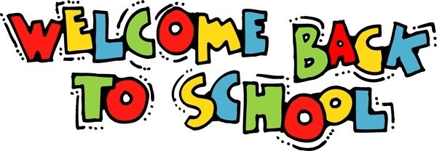

Welcome Students and Parents

to

Blythe Elementary School

2023-2024

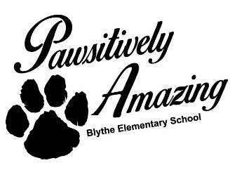

I am Ms. Chase, one of the Special Education Teachers here at Blythe Elementary School. As an Interrelated Special Education Teacher, I will adapt general education lessons and teach various subjects, such as reading, writing, and math, to students with mild and moderate disabilities. In addition, I will be working closely with student’s general education teachers to be actively involved and engaged in all aspects of instruction through sharing ideas, strategies, and using techniques for varied and effective instruction for students with disabilities.

We have many expectations for our students here at Blythe Elementary. Students are to come to school each day prepared to learn and preserve a positive learning environment (no fighting/bullying) allowed. If your student will be absent, it is very important that you notify the school or email his/her teachers. Parents, please update any changes made to contact information throughout the school year, address, phone numbers, and contact information for people allowed to pick up your student from school. I am looking forward to working with you and your students over the course of the school year. Please feel free to call the school during my planning time with any questions or concerns.

**Classroom** **Rituals and Routines**

* Students are expected to arrive on time prepared for class.
* Students should use either an agenda or notebook to keep track of all assignments and homework.
* Class will start each day with a bell ringer activity and temperature check (feeling sad, happy?)

**“What’s Important”**

* Technology Use: Laptops and Desktop Computers are used for Educational Purposes Only
* No Cell Phone Use in Class

**Positive Behavior Rewards**

Positive behavior forms will be issued to Administrative Staff throughout the school year to promote student’s participation in PBIS, a framework that promotes positive behavior and creates supportive environments in schools.

**Behavior that Interferes with Learning:**

1st offense- verbal warning

2nd offense- parent contact

3rd offense- discipline referral

**Grading Policy**:

**90-100 = A**

**80-89 = B**

**75-79 =C**

**70-74 = D**

**69 and below = F**

**Helpful Resource Websites:**

* **I Ready Lessons in Reading and Math**

**(Individualized prepared for students)**

**(Teacher Assigned Lessons)**

* **EPIC for reading materials based on Students Lexile Level**

class code: ekg7596)

**School Supply List**

**5-highlighters**

1. **2-inch binder**

**1 pack of dividers with tabs**

**4- Composition Notebooks**

**1 pack of black ink pens**

**1 pack of - #2 sharpen pencils**

**6- spiral notebooks**

**6- two- pocket folders**

**1 pack of index cards**

**2 packs of notebook paper**

**1 pair of wired headphones**

**Helpful Resource Websites:**

* **I Ready Lessons in Reading and Math**

**(Individualized prepared for students)**

**(Teacher Assigned Lessons)**

* **EPIC for reading materials based on Students Lexile Level**

class code: ekg7596)